Slide 1: Scenario Hook
Title: Too Much on Your Plate?
It’s Monday morning.
Your calendar is full.
Your inbox keeps growing. Your task list keeps growing — and your team needs your attention.
Prompt:
“You can’t do everything yourself. Let’s decide what to Delegate, Defer, or Do.”
“Most leaders don’t lack effort — they lack decision space.”
(No facts yet. Hook first.)

Panel Discusion:
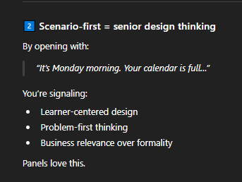
• This learning is about your real problems
• You don’t need to prepare — just step into the situation

Slide 2: The Cost of Task Overload (FACTS)
Title: Why Task Overload Is a Leadership Risk
Facts (short & powerful):
- Frequent task switching can reduce productivity by up to 40%
- Leaders facing high cognitive load show lower decision quality
- Leaders who don’t delegate face higher burnout risk
Insight line:
Overload isn’t about time — it’s about decision fatigue.
🎤 Panel explanation:
“These facts explain why we must simplify decisions, not add more work.”
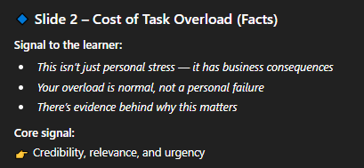

Slide 3: Eisenhower Matrix – Evidence-Based Prioritization
Title: Urgent vs Important
Fact-based insight:
- Research shows people over-prioritize urgent tasks even when they have low impact
- High-performing leaders spend more time on important but not urgent work
Display the 2×2 matrix visually.
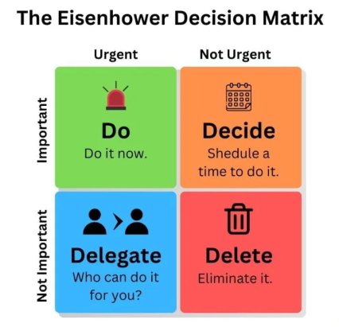
Key message:
Urgency grabs attention. Importance drives outcomes.
🎤 Panel-ready line:
“The Eisenhower Matrix corrects a natural cognitive bias toward urgency.”
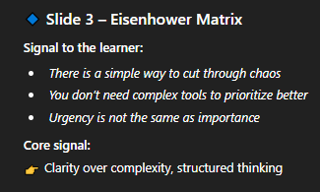

Slide 4: Why Leaders Don’t Delegate (Behavioral Theory)
Title: Common Delegation Traps
Introduce behavioral reasons, not excuses:
- Control bias: “I can do it better myself”
- Time illusion: Delegation feels slower short term
- Risk aversion: Fear of mistakes or rework
Insight:
Overload is often a decision problem, not a workload problem.
This shows behavioral science thinking.
Title: The Brain Under Pressure
Light learning science (very interview-friendly):
- The brain can handle limited decisions at once
- Too many tasks increase decision fatigue
- Simple decision frameworks reduce mental effort

Panel Discussion:
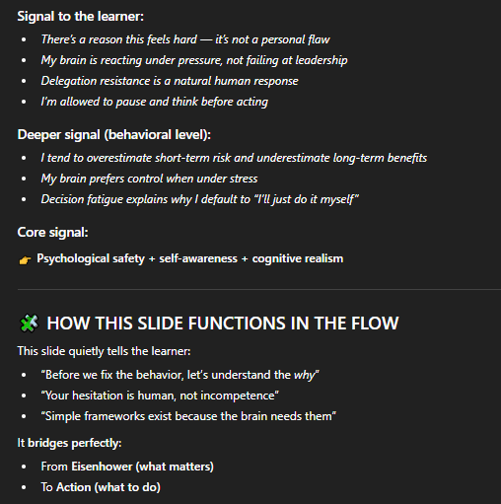

Slide 5: Decision Framework (Micro Concept)
Title: A Simple Decision Lens
Use a 3-column layout with icons:

🟢 Do Myself
- High impact
- Requires my authority or expertise
- Time-sensitive

🔵 Delegate
- Can develop team skills
- Clear instructions possible
- Low risk if supervised

🟡 Defer
- Not urgent
- Can wait without impact
- Needs better timing
Instruction:
Use this lens to decide your next move.
⚠️ Keep this slide very light (no paragraphs).

Panel Discussion
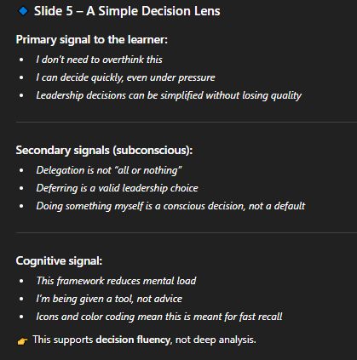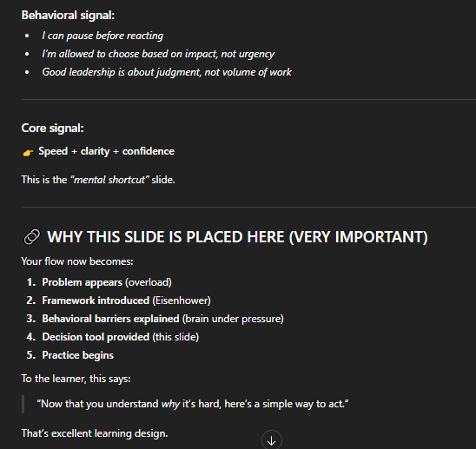

Slide 6: Interactive Scenario (Core Practice)
Title: What Would You Do?
Scenario text:
You have the following tasks today:
Present 3 task cards (clickable or drag-and-drop):
- Preparing quarterly performance slides for leadership
- Reviewing a team member’s draft report
- Responding to a non-urgent internal survey
- Approving a critical budget request
- Updating a routine report
- Booking a team lunch
Interaction (recommended):
- Drag each task into:
  - Delegate
  - Defer
  - Do Myself
(This is easy and impressive in Storyline.)
Answers
For each task, show layer-based feedback:
Example:
- Quarterly slides, Approving a critical budget request → Do Myself
✔ High impact and visibility, Requires leader’s judgment, authority, or accountability, Errors have reputational or financial risk
- Draft report, Updating a routine report → Delegate
✔ Builds team capability, Clear expectations can be set, Low to moderate risk if reviewed
- Survey, Booking a team lunch → Defer
✔ Low impact on core outcomes, No immediate consequences, Can be scheduled later or batched
Coaching line:
Delegation isn’t about offloading work — it’s about multiplying impact.

Slide 7: From Priorities to Decisions (Bridge Slide)
Title: Turning Priority into Action
Map Eisenhower to action:
- Important + Urgent → Do Myself
- Important + Not Urgent → Plan / Delegate
- Not Important + Urgent → Delegate
- Not Important + Not Urgent → Defer
Fact:
- Leaders who consistently delegate low-impact urgent tasks report higher strategic focus
This slide shows logic, not opinion.

Why this works;
Leaders who consistently delegate low-impact tasks regain time for strategic thinking.
Panel Discussion:
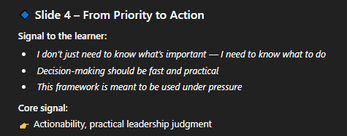

Slide 8: Why Leaders Hesitate to Delegate (FACT + BEHAVIOR)
Title: Why Delegation Feels Risky
Evidence-based reasons:
- Leaders overestimate the risk of delegation and underestimate team capability
- Fear of short-term errors outweighs long-term productivity gains
- Lack of clear checkpoints increases perceived risk
Insight:
Delegation fails when risk is unmanaged — not when tasks are shared.
This sets up risk management cleanly.
Checklist (job-aid style):
- Ask: Does this require me?
- Ask: Can this grow someone else?
- Ask: What happens if I wait?
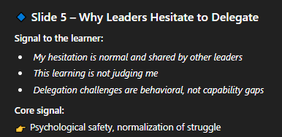

Slide 9: Risk Management Lens (FACT-BASED)
Title: Delegation with Control
Introduce 3-risk lens:
- Impact Risk – What’s the consequence of failure?
- Capability Risk – Does the person have or can build the skill?
- Control Risk – Can progress be reviewed?
Fact:
- Delegation with checkpoints significantly reduces rework and quality issues
Key message:
Leaders don’t give up accountability — they manage risk differently.

Panel discussion
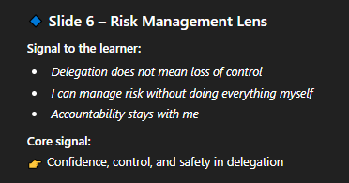

Slide 10: Drag-and-drop

Instruction (On-screen)
Drag each task into the correct risk category.

📦 TASK CARDS (Reuse or Slightly Modify)
- Final sign-off on compliance documentation
- Preparing a first draft of a client presentation
- Sending routine project status updates
- Approving an exception to policy
- Coordinating meeting logistics
- Reviewing final financial numbers

🧱 DROP ZONES (Risk Lens)

🔴 High Risk – Retain Ownership
- Legal, financial, or reputational impact
- Requires formal authority
- Low tolerance for error

🟡 Medium Risk – Delegate with Oversight
- Clear guidelines exist
- Review or checkpoint possible
- Errors are correctable

🟢 Low Risk – Safe to Delegate
- Routine or administrative
- Learning opportunity
- Minimal impact if delayed or revised

✅ MODEL ANSWERS (DEFENSIBLE)

🔴 High Risk – Retain Ownership
- Final sign-off on compliance documentation
- Approving an exception to policy
- Reviewing final financial numbers

🟡 Medium Risk – Delegate with Oversight
- Preparing a first draft of a client presentation

🟢 Low Risk – Safe to Delegate
- Sending routine project status updates
- Coordinating meeting logistics

Panel Discussion
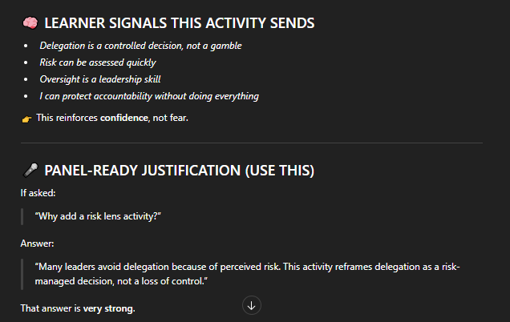

Slide 11: Judgment Question (MCQ)
Title: Leadership Judgment Check
Question:
Which task should leaders avoid delegating?
Correct:
✅ High-impact, high-risk decisions
• Skill-building tasks
• Routine admin work

Why:
Errors at this level carry disproportionate organizational risk.
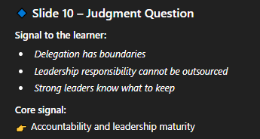

Slide 12: Takeaway + Job Aid
Title: Focus, Delegate, De-risk
Evidence-backed takeaways:
- Delegation increases leader focus
- Prioritization improves decision quality
- Risk-managed delegation builds stronger teams
Title: Focus, Delegate, De-Risk
3-step rule:
- Prioritize what matters
- Decide the right action
- Manage risk — don’t avoid it
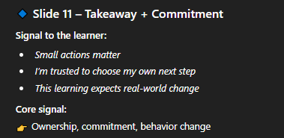
Final CTA:
Delegate tasks — retain accountability.

“Each slide is designed to send a specific signal to the learner — from psychological safety, to clarity, to confidence in decision-making. The goal wasn’t just content delivery, but shaping how leaders feel about delegation and prioritization.”

🧠 LIKELY PANEL QUESTIONS & STRONG ANSWERS

Q1: Why did you choose microlearning for leaders?
Answer:
Leaders operate under constant time pressure. Microlearning respects that constraint while still allowing focused practice. The goal here isn’t knowledge transfer — it’s improving decision quality in real situations.

Q2: Why use drag-and-drop interactions?
Answer:
Drag-and-drop mirrors the mental sorting leaders already do when prioritizing tasks. It externalizes their decision process and allows immediate feedback, which improves retention and transfer.

Q3: Why include theory like Eisenhower and risk management?
Answer:
Frameworks give leaders language and structure for decisions they already make intuitively. I kept theory concise and immediately applied it, so it supports judgment rather than overwhelming the learner.

Q4: How would you measure effectiveness?
Answer:
In a real rollout, I’d track post-learning behavior such as increased delegation frequency, reduced leader workload, and qualitative manager feedback. This module is designed to support behavior change, not just completion.

Q5: How would you scale this?
Answer:
By adding role-specific scenarios, advanced risk cases, or follow-up nudges. The framework remains consistent while complexity increases.

